**Hong Kong Institute of Vocational Education**

**Department of Information of Technology**

**Higher Diploma in Data Science and Analytics (IT114116)**

**ITE3006 Information Technology Essentials - Web**

**End-of-Module Assessment**

**Report**

Class: 1B

Group: 3

Member list:

|  |  |  |
| --- | --- | --- |
| Name | SID | Contribution to the project (%) |
| Tang Ching Him | 200116417 | 60 |
| Chan Kwun Man | 200423326 | 40 |

1. **Topic**

We have chosen “Vocaloid fanclub” to be the topic for this assignment.

Vocaloid is a singing voice synthesizer software product. It enables users to synthesize "singing" by typing in lyrics and melody and also "speech" by typing in the script.

In this assignment, we aim to promote Vocaloid (virtual singers) and attract newcomers for the fanclub.

1. **Site Map**

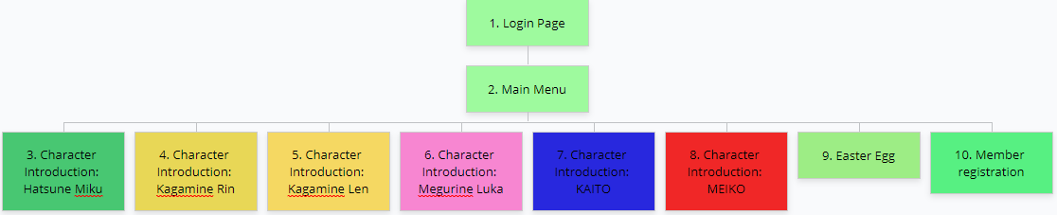

1. **Appearance of Webpages**
2. Login Page

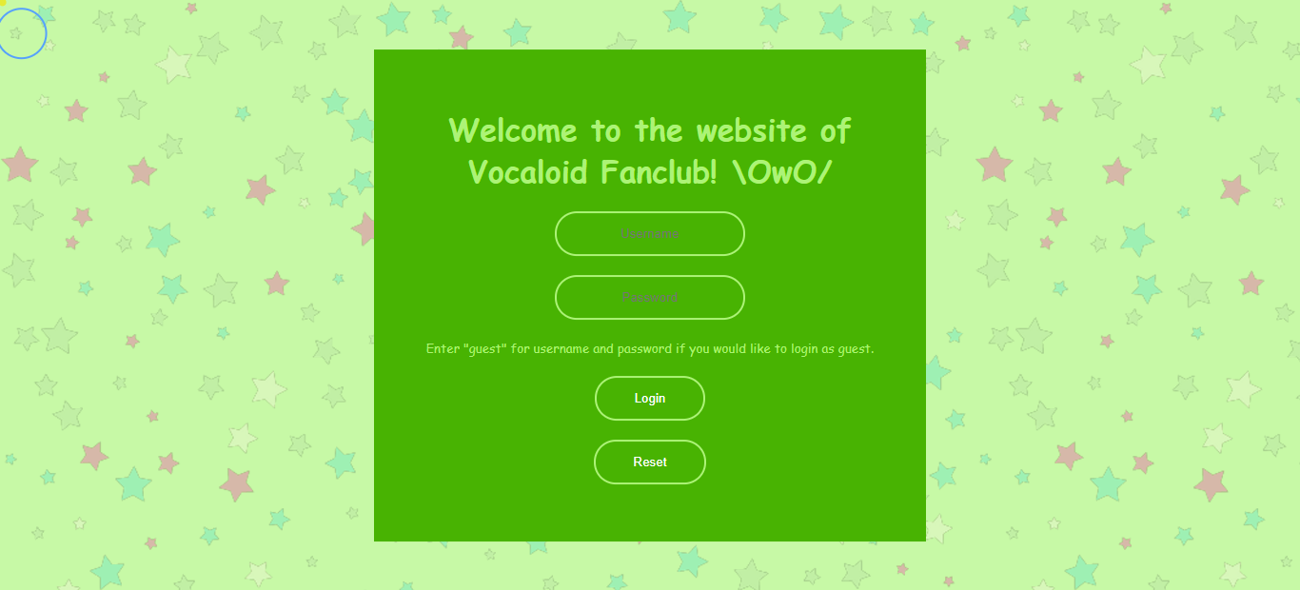

1. Main Menu

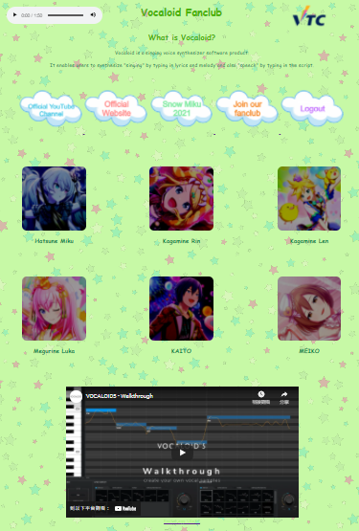

Easter Egg

1. Character Introduction: Hatsune Miku

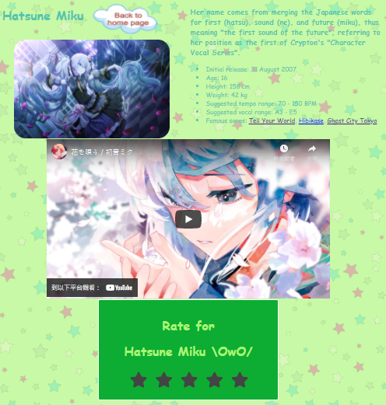

1. Character Introduction: Kagamine Rin

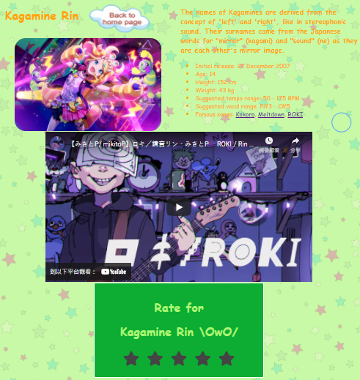

1. Character Introduction: Kagamine Len

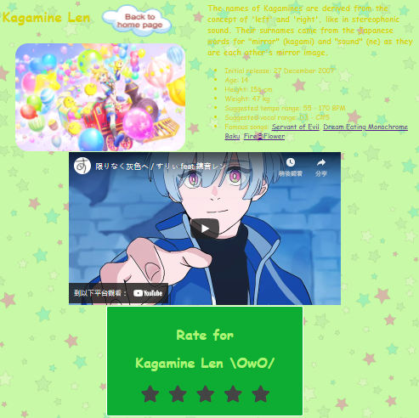

1. Character Introduction: Megurine Luka

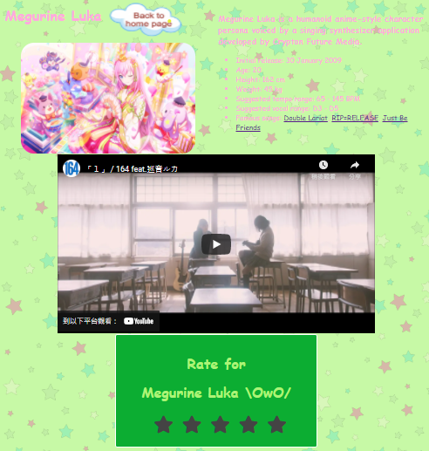

1. Character Introduction: KAITO

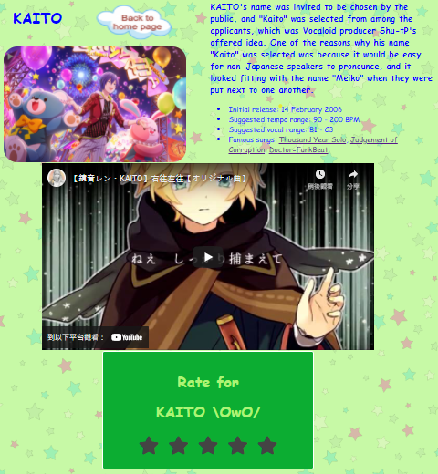

1. Character Introduction: MEIKO

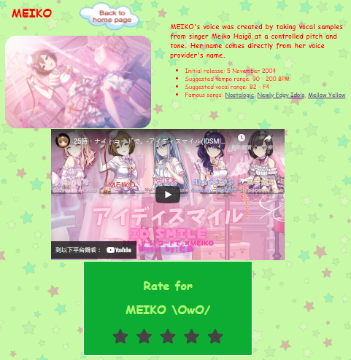

1. Easter Egg

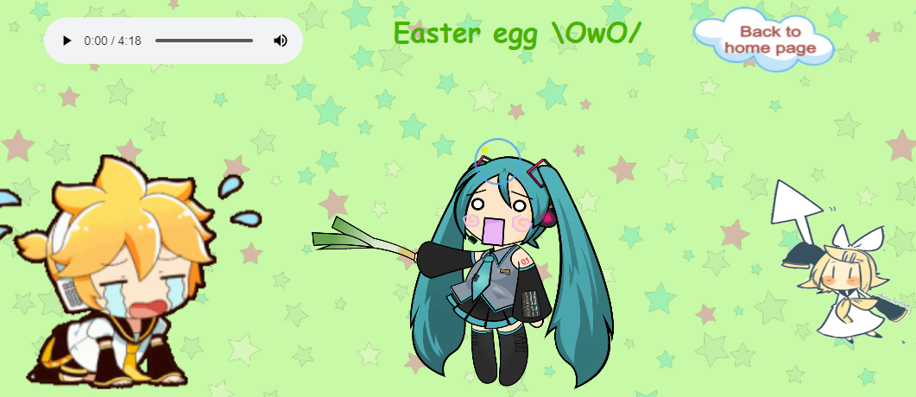

1. Member Registration

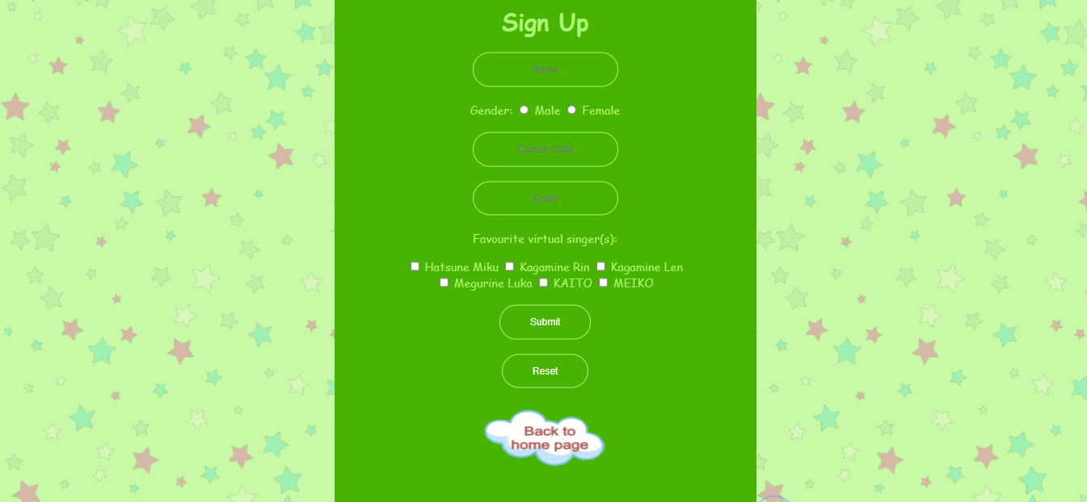

1. **Application of CSS**
2. Customized cursor

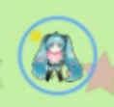



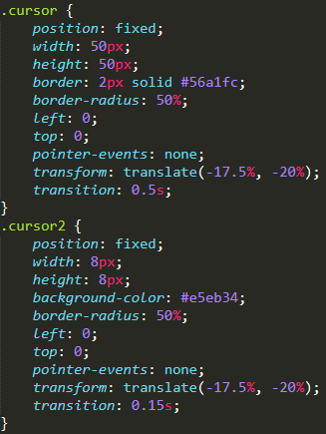 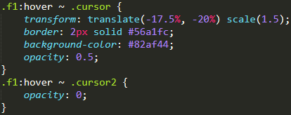

When newcomers visit this website, the cursor would be changed to an image (cursor.png). Besides, there is a circle around to the image and a yellow dot near the image for the sake of clearer pointing.

1. Font style, background colour, background image, and structure arrangement







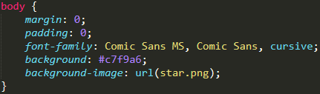

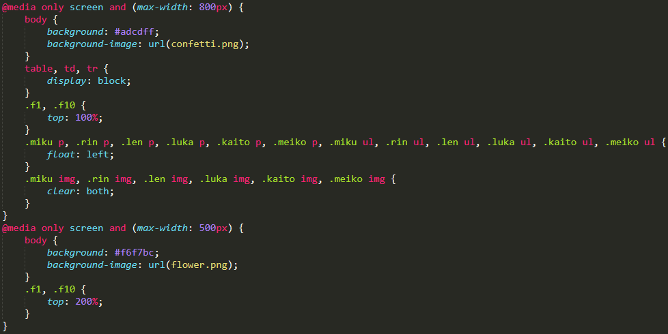

A lovely font style (cursive Comic Sans) is used to match the theme. Media queries are also applied to improve visitors’ experience. The background colour, the background image and the structure arrangement would be changed when the size of the window is changed.

1. Form design and customized properties of HTML attributes

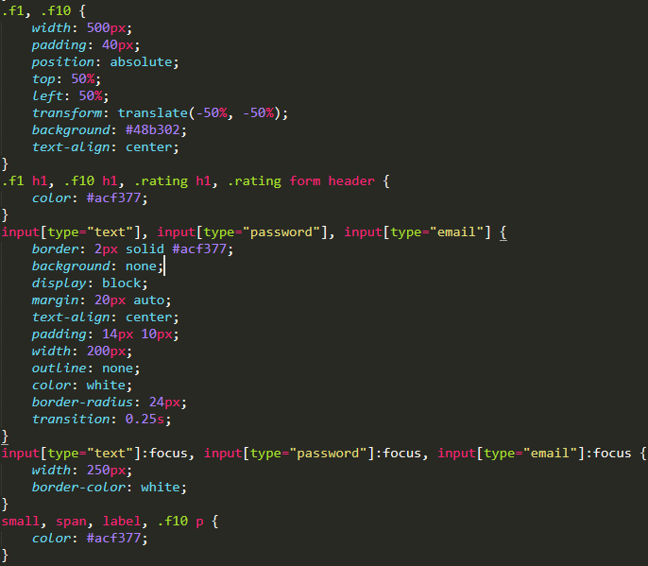

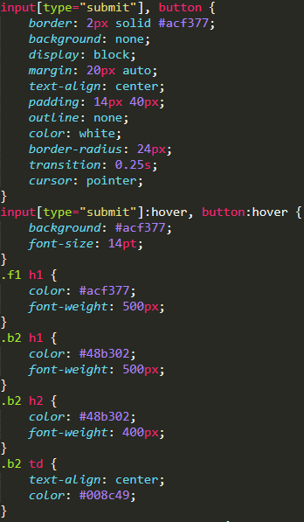

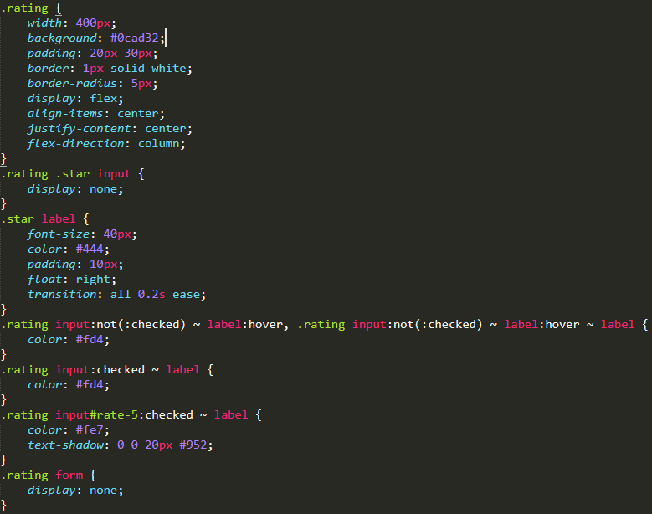

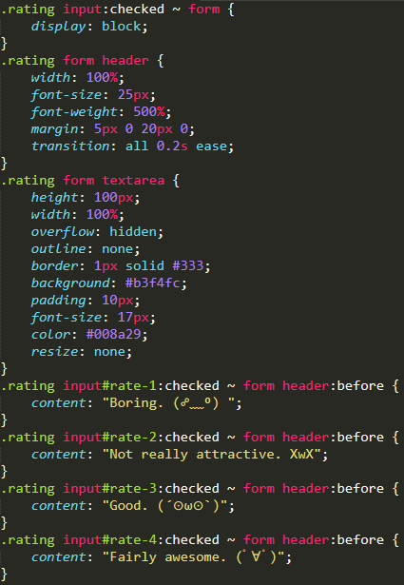



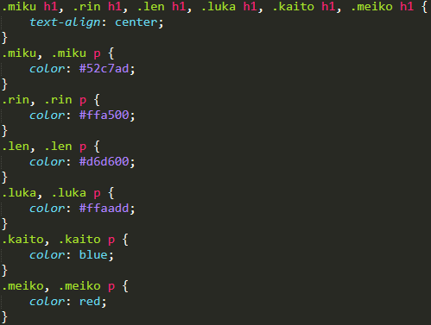

Numerous CSS code is used for structure arrangement of the website, including alignment, text colour, size, margin, border, and so on.

1. Image effects

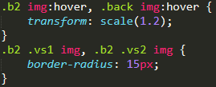

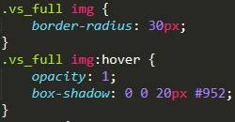

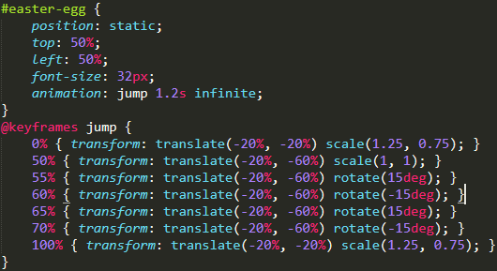

Most of the images on the website would be enlarged when they are hovered. Also, the images in character introduction pages are round-angled and shadow effects are applied when the images are hovered. Bouncing animation effects are applied to the images in the Easter Egg page.

1. **Application of JavaScript**
2. Login validation

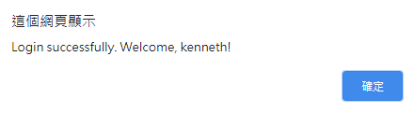

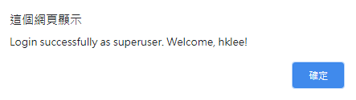

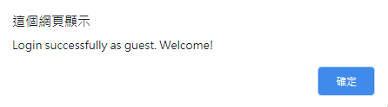

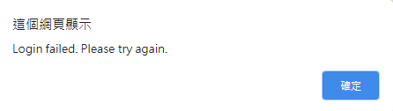

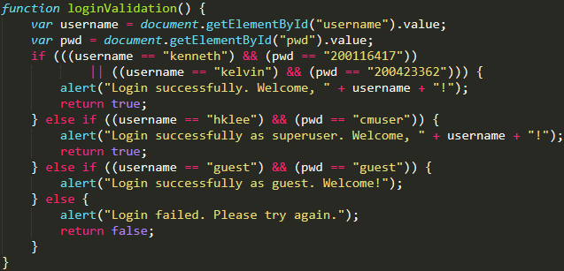

Visitors may login as normal users, super users, or guests. A message will be prompted when a valid combination of username and password is not given.

1. Image hovering effects

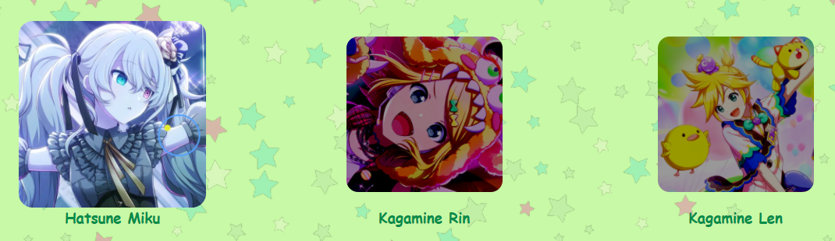

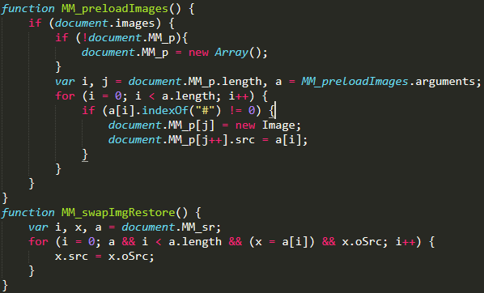

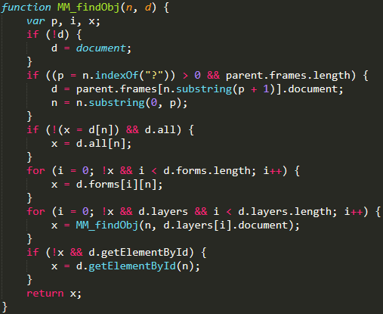

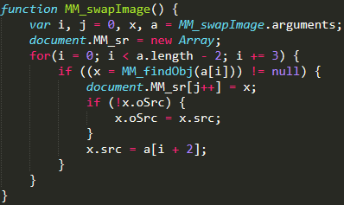

Character images in Main Menu page will be lightened up when they are hovered. A number of JavaScript functions is used for this hovering effect.

1. Registration form validation

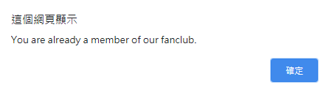

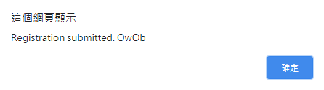

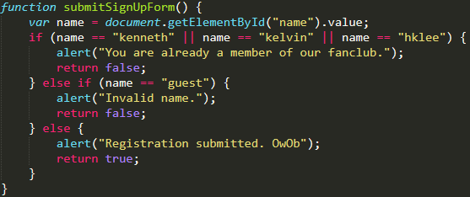

A corresponding responsive message will be prompted when the visitors submit the registration form with and without specific names respectively.

1. Resetting the form when it is submitted



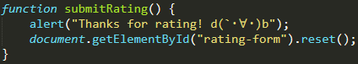

A simple JavaScript function is used for resetting the content of a rating form once it is submitted.

1. Cursor animation effect

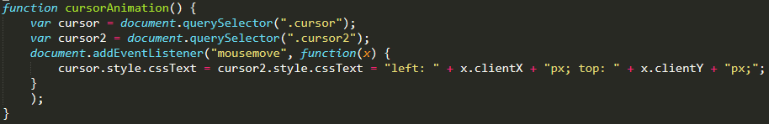

A JavaScript function including an event listener is used for creating cursor animation effect.

1. **Validation and Processing of Form Data using HTML**
2. Login validation

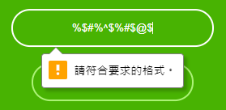

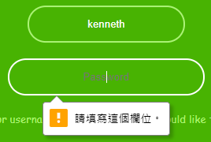



Username and password are required before submitting the login form. Besides, the username should contain alphabetical letters in lower case only.

1. Registration form validation

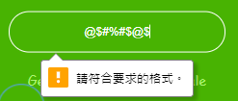

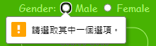

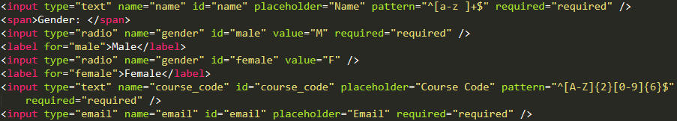

Name, gender, course code, and email address are required before submitting the registration form. In addition, the name should contain alphabetical letters in lower case and spaces only as well as the course code should start with two alphabetical letters in upper case and be followed by six digits. Furthermore, only email address with proper format will be accepted for the “Email” field.

1. **Reference**
2. Vocaloid. In Wikipedia. <https://en.wikipedia.org/wiki/Vocaloid>
3. Hatsune Miku. In Wikipedia. <https://en.wikipedia.org/wiki/Hatsune_Miku>
4. Kagamine Rin & Len. In Wikipedia. <https://en.wikipedia.org/wiki/Kagamine_Rin/Len>
5. Megurine Luka. In Wikipedia. <https://en.wikipedia.org/wiki/Megurine_Luka>
6. KAITO. In Wikipedia. <https://en.wikipedia.org/wiki/Kaito_(software)>
7. MEIKO. In Wikipedia. <https://en.wikipedia.org/wiki/Meiko_(software)>